**Higher Education Application of Virtual Reality for Technical Documentation Instruction**

**Todd Birch, Northern Arizona University Instructor**

**Abstract**

In a time of staggering technological progress, many instructional strategies are combining the new with the old. Professional writing students have traditionally been taught how to produce finished products that speak to an audience through organization, direct language, and focused content. One important area of study that students apply these lessons to is technical documentation. Students learn how to work with text and graphics to deliver a documentation product that often includes step-by-step instructions, detailed explanations, and matching illustrations. As technology changes and advances, new opportunities are available to expand the scope of technical documentation. A dynamic technology that is finding usage as an educational and commercial platform is virtual reality. Virtual reality produces a fully immersive user experience that excels at visual clarity, and it is finding many creative uses for higher education instruction. The use of virtual reality to support technical documentation instruction will examine how VR technology application has increased, how to employ it in different higher education curriculums, and weigh its drawbacks.

**Keywords**

Virtual Reality in Higher Education; Technical Documentation; Education Technology; Active Learning

**1. Introduction**

Virtual reality is opening up new possibilities for instruction on college campuses. With the increased access to affordable virtual reality (VR) hardware and software, many higher education disciplines are finding this technology useful for developing active learning instruction. Virtual reality use as an educational technology is enabling new collaborative partnerships between on-campus VR labs and different academic programs. Psychology, chemistry, nursing, and archeology are just some of the study programs that are embracing virtual reality as an effective delivery platform for instruction.

Technical writing students learn how to create clear and concise written material for different professional applications. However, traditional technical documentation is often limited to text, illustrations, and other two-dimensional presentations. While these information delivery systems can do the job, there are situations that need greater clarity and the ability to visualize a situation to solve a problem. Guesswork and trial-and-error could be significantly reduced if enhanced, three-dimensional renderings were available. By combining aspects of virtual reality programming with concise technical writing acumen, students could bring interdisciplinary energy to a new academic pursuit.

**2. Objectives**

This research study will examine the foundations of technical documentation and virtual reality. It will look at the current state of virtual reality technology in higher education, including an analysis of how to blend VR tech with various academic programs and what it could bring to technical documentation. The research will look at the successes and drawbacks to VR instruction and explore student opinions and pedagogy acceptance. The study will also examine the economics of using virtual reality devices on a higher education campus and the possibilities of expanding the use of VR technology in instruction.

*2.1 Virtual Reality Meets Chemistry*

The idea of combining VR technology with technical documentation drew interest with the collaboration between Northern Arizona University’s School of Communication Advanced Media Lab and the NAU Department of Chemistry. The two academic units work together to develop virtual reality chemistry labs that take their students into a completely immersive VR environment, where they can handle and manipulate molecular models. By rendering molecules in a way that students can virtually assemble, rearrange, and complete instructional materials in a virtual setting, the Chemistry Department is creating a method of instruction that moves beyond lectures and diagrams towards an engaging active learning environment.

*2.2 Goals*

With this one example of academic collaboration to stimulate thinking, combining technical documentation with VR technology exploration began. By discovering how other academic programs are using the technology, research can shed light on the possibilities and obstructions for further interdisciplinary collaboration. It is also important to look at active learning versus passive learning and how that relates to higher education instruction. Finally, this report will look to grasp the basic economics of developing virtual reality programs for instruction and considerations for any negative aspects.

**3. Defining Virtual Reality**

Virtual reality describes interactive technology that allows users to experience an artificially constructed 3D space in real time (González-Zamar, M.D., & Abad-Segura, E. (2020). VR users become part of a computer-generated interactive environment with specific virtual reality hardware. The most common hardware used to access a VR environment are goggles, also known as head-mounted displays (HMD’s) (Fabris, C. P., et al. (2019). By wearing these HMD devices, the user enters a three-dimensional setting where they can interact and manipulate

virtual constructs. The manipulation is possible through the use of gyroscopes and sensor technologies built into the HMD’s, sometimes with physical joystick handling (Jantjies et al. (2018).

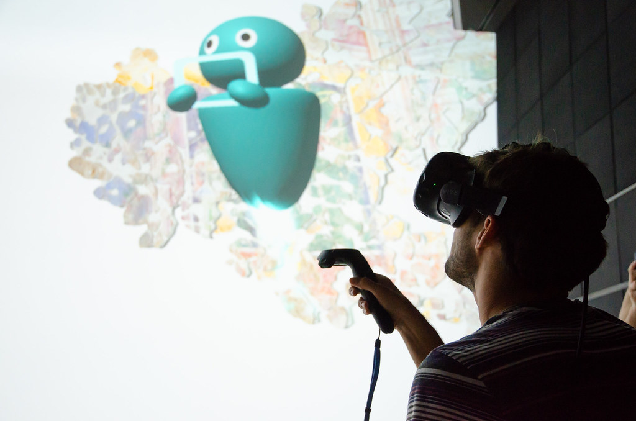

Figure 1. Virtual reality HMD and joystick

HMD’s are not the only interface technologies available for virtual reality. Some VR systems use a Cave Automatic Virtual Environment (CAVE). A CAVE virtual reality system is a large, room-sized immersive platform. It uses multiple cameras, stereoscopic displays, and motion-tracking systems to create a fully immersive VR environment. Because of the size and cost of CAVE systems, exponentially more affordable HMD devices eclipse their use (*Cave Immersive Virtual Reality*. AV & VR Solutions. (2021, July 12).

When discussing the use and benefits of employing HMD virtual reality platforms in higher education settings, it is important to mention some drawbacks. Wearing HMD’s can be a problem for some people. Users may experience discomfort that can include strenuous posture demands, repetitive strain injuries, headset weight and fit, simulator sickness, and disorientation (Radianti et al. (2020). These are not insignificant deterrents to educational use and should be kept in mind when considering how to develop a VR technical documentation course of study.

**4. Defining Technical Documentation**

Technical documentation is the practice of composing details, instructions, procedures and more for specific products. Technical writers use their skills of organization and clear communication to produce the documentation needed to explain processes and details for any number of products or devices. This documentation is often presented via text descriptions and 2D visual supplements. The material is sometimes augmented with audio and video material. Frequent forms of instructions found in printed documentation are image sequences, explosion diagrams, textual annotations and arrows indicating motion (Mohr, P. et al. (2015).

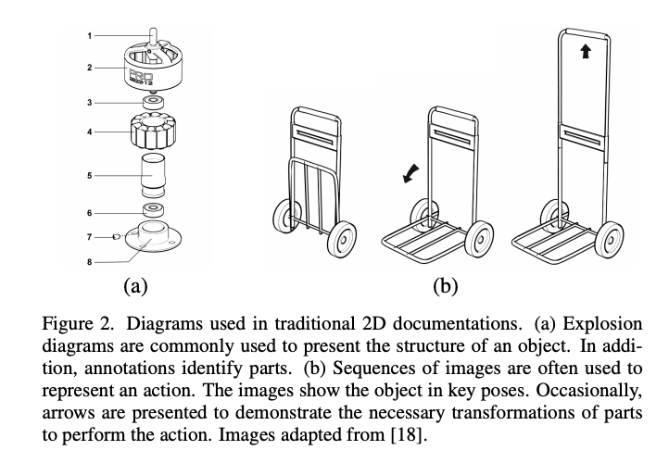

Figure 2. Example of Traditional Technical Documentation

The goal of well-written technical documentation is the delivery of information in a highly usable and accessible presentation. It must speak to a potential range of user expertise and experience, allowing for different readers to find the information they need (Gattullo, M., et al. (2019).

*4.1 Technical Documentation Opportunities*

Technical documentation is a critical component of many commercial enterprises. Competent technical documentation supports the proper use and maintenance of products for countless industries. Historically, text and 2D illustrations deliver the supporting technical documentation. But with technological advances, VR documentation is rapidly growing. Companies such as RE-FLECKT are combining the practical requirements of product documentation with the interactive experience of virtual reality. Specifically, they offer a VR product line that focuses on employee training through virtual enhancement of existing technical documentation (2019 RE'FLEKT GmbH, Retrieved November 16, 2021). As commercial applications grow, there is an instructional opportunity for VR technical documentation. Students are already learning the fundamentals of composing clear and concise documentation. By combining precise composition skills with immersive 3D environments, a path exists for creative instruction that is both highly engaging and practically effective.

**5. Active Learning and Virtual Reality**

Virtual reality technology is finding a home in higher education as an engaging instructional tool. VR’s interactivity and immersive properties are advancing its use as academic programs look to stimulate student’s interest and increase their skills and knowledge. By leveraging the educational technology of virtual reality, lessons are moving away from passive delivery towards active learning with the goal of improving learning outcomes and student engagement.

*5.1 Passive Learning*

To understand active learning, it’s a good idea to understand the idea of passive learning. This is important because many instructional paradigms base themselves on passive learning as a teaching model. Passive learning places emphasis on the instructor of the class, not on the students (Fabris, C. P., et al. (2019). Teachers pour out their knowledge through lectures and presentations with little or no interaction with their class. Students become docile receptacles for information and may have difficulties with motivation and knowledge retention (Ghilay, Y., & Ghilay, R. (2015).

*5.2 Active Learning*

Active learning centers on the idea of students engaging with course lessons through participation, discussion, reflection, and working through problems with both peers and teachers (Ghilay, Y., & Ghilay, R. (2015). Active learning models strive to make students the center of the lessons. This style of teaching highlights student collaboration and focuses on creativity and problem solving to motivate education (Alehegn Sewagegn, A., & M. Diale, B. (2019). By applying active learning strategies to course materials, students are able to retain more details, improve their understanding of lessons, and apply revision of concepts easier (Fabris, C. P., et al. (2019).

*5.3 How Virtual Reality Enhances Active Learning*

Virtual reality naturally lends itself to active learning participation. VR brings students directly into the lesson materials and involves them with movements and manipulations of 3D, computer rendered environments. Active learning benefits for virtual reality instruction include facilitating group work, immersive problem-solving lessons, and excitement with working in an entertaining medium. In fact, one of the greatest values of including VR in higher education instruction is the enjoyment that students have working in a colorful and dynamic virtual experience (González-Zamar, M.-D., & Abad-Segura, E. (2020).

**6. Virtual Reality Instruction at NAU**

In the past several years, Northern Arizona University has created two virtual reality labs on campus. The lab locations are at Cline Library and in the School of Communication. The Department of Chemistry was one of the first programs to embrace VR education technology for interactive lessons. Chemistry and the Advanced Media Lab in the School of Communication collaborated on a virtual reality simulation designed to allow students to complete assignments on molecular structure in VR. Students enter the 3D setting, examine different molecular models, and then manipulate them to change their characteristics. What began as a simply rendered VR environment was refined and updated to give an impressively detailed and highly interactive model for students to learn critical chemistry concepts.

*6.1 Who is Driving the Use of VR on Campus?*

One of the leaders of virtual reality educational technology on the NAU campus is Giovanni Castilla, the Advanced Media Lab (AML) Manager at NAU’s School of Communication. He piloted the partnership with the Department of Chemistry and is pursuing several other collaborations between academic departments on campus.

Since creating the virtual reality structure for Chemistry, Giovanni Castilla and the AML have created several other VR educational environments. These include collaborations between social science departments such as psychology and sociology, and work with the physical science discipline of nursing. The AML partners with NAU Information Technology to help fund the infrastructure and to bring awareness to the possibilities of virtual reality. Excitement in NAU’s Information Technology department motivates improvement of learning possibilities and encourages the use of virtual reality tools for instruction. The partnership between education stakeholders and computer science is driving multiple cross-disciplinary partnerships to develop.

Current VR programs being implemented by NAU’s Advanced Media Lab give a picture of what is possible.

*6.2 Virtual Reality for Social Sciences*

Social Science departments are increasingly interested to apply virtual reality for course studies (González-Zamar, M.-D., & Abad-Segura, E. (2020). For NAU’s Department of Psychological Sciences, a VR environment for testing inherent cognitive biases is critical for collecting data to analyze behavior. The AML works with psychology instructors to develop a VR experience where students enter a virtually created social situation and interact with other participants. The educational experience comes through data collection and analysis by the students. Students view and collate behavior patterns, then examine them using the traditional lessons from psychology instruction. The virtual reality technology engages the students and brings first-hand experience of biases that are critical to understanding the data collection results.

*6.3 Virtual Reality for Physical Sciences*

The Advanced Media Lab is beginning to partner with NAU’s School of Nursing to virtualize human anatomy instruction. They are introducing the use of a commercial VR program called HoloAnatomy that provides users with a chance to view and manipulate 3D images of the human body. Not only does this program provide a risk-free environment for teaching, but offers the chance for remote participants who are not able to attend the NAU Mountain Campus. NAU’s IT department is keen to pursue more opportunities like this to increase student participation from remote locations. In the context of providing an active learning experience, virtual reality has the potential to improve learning outcomes for biomedical science students as it allows students to visualize and interact with digital representations of dynamic objects and complex concepts (Fabris, C. P., et al. (2019).

*6.4 Survey of Student Perceptions of Virtual Reality Use*

As the use of virtual reality for educational purposes grows, student attitudes are important to think about. Ultimately, student acceptance of VR as both an instructional aide and as a way to engage learners is critical for success. The data from a survey conducted of undergraduate student view’s on VR use at the University of the West of Scotland provides some compelling information (Baxter, G., & Hainey, T. (2019).

The survey posed a pair of questions to a total of 100 higher education student participants. The first question asked how strongly they agreed that virtual reality was an innovative application that had pedagogical benefits. An overwhelming number of participants, 89%, either agreed strongly or agreed with that proposition.

Figure 3. Percentage of students who believe in VR inclusion for teaching

A second question asked the same students how strongly they agreed that virtual reality technology would enhance their learning experience. 68% of the students strongly agreed or agreed with this notion.

Figure 4. Percentage of students who believe that VR enhances instruction

The conclusion reached through this survey is that significant student interest exists to apply VR to course studies and a general acceptance of using VR educational technology as a learning aid. We should note that the survey does not speak directly to student’s experience with using virtual reality as an educational technology, only to a willingness and openness to its use in the classroom.

**7. Virtual Reality Hardware Costs**

The Advanced Media Lab in the School of Communication developed through a partnership with NAU’s Information Technology department. The two created a shared space for research, instruction, and student involvement for virtual reality and NAU’s eSports. Overall, the entire build cost over $120 thousand dollars, with nearly $11 thousand dollars allocated to virtual reality hardware. Of particular interest is how affordable the Oculus HMD’s used for instructional virtual reality are.

|  |  |
| --- | --- |
| **Virtual Reality Hardware** | Unit Price |
| Oculus Go headset | $ 150.00 |
| Oculus Quest 2 headset | $ 299.00 |
| HTC Vibe headset | $ 799.00 |
| Monopod | $ 259.95 |
| 360 camera | $ 5,995.00 |

Figure 5. AML virtual reality hardware costs

The Oculus Go headsets provide a robust platform for virtual reality access with high quality visual resolution. The low cost of these headsets allows the AML to let students take them outside of the lab setting for use at home or anywhere else with reliable internet access. This flexibility provides a way for students to utilize educational technology without being tethered to one location.

**8. Technical Documentation Instruction Using Virtual Reality**

With NAU’s virtual reality infrastructure already in place, a partnership could develop that incorporates technical documentation instruction. This collaboration would combine the lessons on audience recognition, structured organization, and clear communication that are central to technical writing, and create immersive 3D representations.

*8.1 The Creation of Virtual Reality Environments for Technical Documentation*

Technical documentation integration with virtual reality technology need not involve extensive programming. Simple virtual reality documentation happens with 3D cameras and Adobe editing software already available in the AML. The captured images can easily be reframed into an immersive VR environment. Users looking for documentation would simply engage their HMD’s and enter the virtual reality program to choose an area to examine. This entry-level VR creation could then lead to more extensive documentation design that could explore explosion diagrams and other interactive features.

*8.2 Resources Required to Make Technical Documentation a VR Experience*

There are two basic things required to create a VR environment for technical documentation, the plan of what to document, and the technology to capture it. Students plan what to describe for documentation purposes in a technical writing course. The student’s instructional blueprint will then be recorded and translated into virtual reality using the hardware, software, and creative personnel from the AML.

**9. Conclusion**

Northern Arizona University has the elements in place to create a partnership between technical documentation and virtual reality. NAU has a robust virtual reality infrastructure and the Advanced Media Lab has practical experience delivering 3D, fully-immersive VR environments for a wide range of academic programs. The AML has the full support of Information Technology, which provides crucial financial and personnel support for their projects. A combined VR and technical documentation class could also benefit enrollment at NAU by creating an attractive and innovation class that could be marketed to students. The tools are in place, it only takes the drive and desire to create a new teaching tool that will benefit both students and the University.

There are clear advantages to students of technical documentation to learn how to incorporate VR into their lessons. They will learn innovative, virtual reality practices that are currently being adopted for education and commercial use (Carruth, D. W. (2017). Students will also benefit from an active learning pedagogy, which increases engagement, retention, and user enjoyment. Although not every student will embrace VR instruction, a cross-disciplinary partnership could open teaching and learning opportunities for all involved.

**10. References**

Alehegn Sewagegn, A., & M. Diale, B. (2019) Empowering learners using active learning in Higher Education Institutions. *Active Learning – Beyond the Future.* https://doi.org/10.5772/intechopen.80838

Baxter, G., & Hainey, T. (2019). Student perceptions of virtual reality use in higher education. *Journal of Applied Research in Higher Education*, *12*(3), 413–424. https://doi.org/10.1108/jarhe-06-2018-0106

Carruth, D. W. (2017). Virtual reality for education and workforce training. *2017 15th International Conference on Emerging ELearning Technologies and Applications (ICETA)*. https://doi.org/10.1109/iceta.2017.8102472

*Cave Immersive Virtual Reality*. AV & VR Solutions. (2021, July 12). Retrieved November 16, 2021, from https://www.mechdyne.com/av-vr-solutions/solutions/virtual-augmented-reality/cave/.

Fabris, C. P., Rathner, J. A., Fong, A. Y., & Sevigny, C. P. (2019). Virtual reality in higher education. *International Journal of Innovation in Science and Mathematics Education*, *27*(8). https://doi.org/10.30722/ijisme.27.08.006

Gattullo, M., Scurati, G. W., Fiorentino, M., Uva, A. E., Ferrise, F., & Bordegoni, M. (2019). Towards augmented reality manuals for industry 4.0: A methodology. *Robotics and Computer-Integrated Manufacturing*, *56*, 276–286. https://doi.org/10.1016/j.rcim.2018.10.001

Ghilay, Y., & Ghilay, R. (2015). TBAL: Technology-based Active Learning in Higher Education. *Journal of Education and Learning*, *4*(4). https://doi.org/10.5539/jel.v4n4p10

GmbH, R. E. F. L. E. K. T. (n.d.). *Augmented reality for technical documentation in the industry*. Augmented Reality for Technical Documentation in the Industry. Retrieved November 16, 2021, from https://www.re-flekt.com/portfolio-item/augmented-reality-technical-documentation.

González-Zamar, M.-D., & Abad-Segura, E. (2020). Implications of virtual reality in arts education: Research analysis in the context of Higher Education. *Education Sciences*, *10*(9), 225. https://doi.org/10.3390/educsci10090225

Jantjies, M., Moodley, T., & Maart, R. (2018). Experiential learning through virtual and augmented reality in Higher Education. *Proceedings of the 2018 International Conference on Education Technology Management - ICETM 2018*, 42–45. https://doi.org/10.1145/3300942.3300956

Mohr, P., Kerbl, B., Donoser, M., Schmalstieg, D., & Kalkofen, D. (2015). Retargeting technical documentation to augmented reality. *Proceedings of the 33rd Annual ACM Conference on Human Factors in Computing Systems*. https://doi.org/10.1145/2702123.2702490

Radianti, J., Majchrzak, T. A., Fromm, J., & Wohlgenannt, I. (2020). A systematic review of immersive virtual reality applications for higher education: Design Elements, lessons learned, and research agenda. *Computers & Education*, *147*, 103778. https://doi.org/10.1016/j.compedu.2019.103778